|  |
| --- |
| **SOUTHERN CROSS UNIVERSITY** |

**ASSIGNMENT COVER SHEET**

For use with online submission of assignments

Please complete all of the following details and then make this sheet the **first page of each file of your assignment – do not send it as a separate document.**

Your assignments must be submitted as either **Word documents, text documents with .rtf extension or as .pdf documents**. If you wish tosubmit in any other file format please discuss this with your lecturer well before theassignment submission date.

|  |  |
| --- | --- |
| Student Name: | **Yi Zhong** |
| Student ID No.: | 23348000 |
| Unit Name: | **Developing the User Experience** |
| Unit Code: | **CSC10215** |
| Tutor’s name: | **Zhu Ya chao** |
| Assignment No.: | **Assignment 2, Design Documentation** |
| Assignment Title: | **Group Game Project** |
| Due date: | **2020 - 5 - 27** |
| Date submitted: | **2020 - 5 - 27** |

Declaration:

*I have read and understand the Rules Relating to Awards (*[*Rule 3 Section 18 – Academic Misconduct Including Plagiarism*](http://policies.scu.edu.au/view.current.php?id=00140#s18)*) as contained in the SCU Policy Library. I understand the penalties that apply for plagiarism and agree to be bound by these rules. The work I am submitting electronically is entirely my own work.*

|  |  |
| --- | --- |
| Signed:  (please type your name) | ________Yi Zhong ____________________ |
| Date: | ________2020 - 5 - 27____________________ |

**[Ninja Cat]**

**Design Documentation**

By [**Ninja Cat**]

[**Sun Mingrong, Zhong Yi, Teng Zihan**]

Contents

1 Concept Paper 5

1.1 Introduction 5

1.2 Background 5

1.3 Description 5

1.4 Key Features 5

1.5 Genre 6

1.6 Target Age group 6

1.7 Concept Map 7

1.8 Platform 7

1.9 Concept Art 7

1.10 Market Analysis 9

2 Functional Specification 10

2.1 Navigation 10

2.2 User Interface 10

2.3 Storyboards 13

2.4 Media List 18

3 Technical Specification 19

3.1 Technical Specs: Minimum Requirements 19

3.2 Technical Specs: Code Objects 19

3.3 Technical Specs: Data Handling 21

4 User Evaluation and Testing forms 22

4.1 User Evaluation forms 22

User Testing Form 1 22

User Testing Form 2 24

User Testing Form 3 26

4.2 Product Testing forms 28

# Concept Paper

## Introduction

My game is about Ninja cat avoiding obstacles. Although the game is very simple, the exciting concert makes you calm down in this game. Come on, young people, challenge this game together! This game is a kind of game, has a high challenge. The player needs to control the ninja cat to break through as many pillars as possible to save the princess, which may appear at any time the terror of cannibalistic flowers!

## Background

The evil dark king took the princess of Ninja Kingdom, and the Ninja Kingdom needs to send a brave man who is not afraid of life and death to rescue the princess. At this time, a ninja cat of Ninja Kingdom volunteered to become a warrior and stepped into the journey to the dark palace to rescue the princess.

## Description

In this game, ninja cat is moving all the time and will encounter different obstacles. You need to constantly avoid various obstacles, including the dark pillar that blocks you. Of course, in addition to these, there will be some danger in the game. For example, there is a certain probability that the cannibal flowers placed by the evil king will appear on the obstacles. The player needs to pay special attention to these cannibal flowers and control the ninja to avoid these cannibal flowers. At the end of the game, the player's personal ranking will be displayed.

## Key Features

1. Adventure

This game is a very adventurous game. It has many adventurous game elements, such as adventure style story background, exciting and exciting adventure style music, legendary and exquisite adventure

1. Challenge

This game is also a very challenging game. For novice players, this is nothing more than a big challenge. Of course, it is also conducive to stimulate the players' eager pursuit of the challenge heart, so that the players can constantly challenge the game, but not be afraid of the challenge of the game, and keep cycling, so as to constantly stimulate the players' enthusiasm for the game on the other hand.

1. Record ranking

This game has an online high-level scoreboard, which can continuously display the player's score while also displaying the corresponding score level of the player. In addition, if the player continues to receive game rewards, as the player experiences in the game, these rewards will continue to change into points.

## Genre

This game is a horizontal version of the 2D adventure game, inspired by Flappy bird, so its theme is defined as cartoon, fantasy. The character is very cute, so that young people like it very much. The artistic style of the work also borrows from Japanese Shinto religion and ninja culture. With the combination of cartoon and Japanese cultural style. The game is more in line with the preference of young people and the trend of diversified society. There are many successful games that use similar strategies.

## Target Age group

This game is played for 12-26-year-old young people. The game’s user interface is as simple and clear as possible.

Considering that young people are good at receiving information, the game is equipped with rich animation and music to provide users with appropriate feedback. Young people like to have some challenging games, challenging games can arouse their desire. The ranking system in this game is designed to attract users to constantly challenge their own and others' records. Older people tend to be less enthusiastic about challenging, more difficult games. Middle-aged people tend to prefer simple games that can release their pressure due to greater pressure from life and work. Therefore, this game is mainly aimed at young people aged from 12 to 26, who have lower life pressure and have more time to challenge themselves. At the same time, they are very receptive to new things and have strong learning ability.

## 1.7 Concept Map

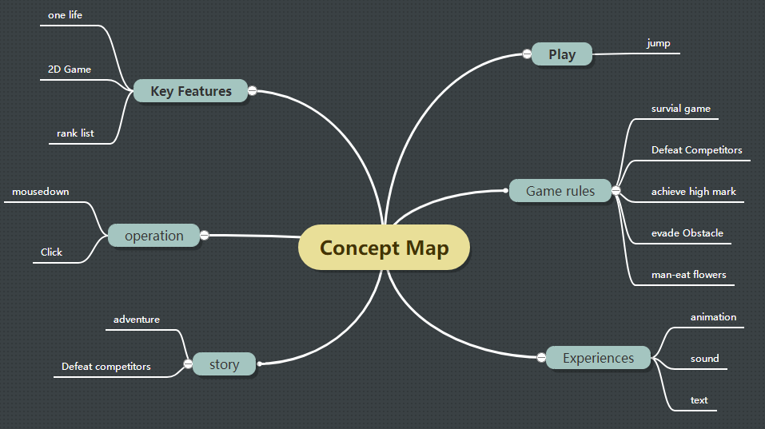

## 1.8 Platform

This game is based on the development of web technology. Therefore, in theory, this game will support multiple platforms. Such as Windows, Mac OSX, Linux, Mobile, Multiple platforms, Internet based, etc.

Chrome 80.0.3987.149 (official version) (64 bit)

The recommended version: Chrome 80.0.3987.149 (official version) (64 bit)

The game runs in Chrome, Safari, Firefox 3.6, and Opera 10.5. IE Internet explorer is not very well supported, and it is recommended to run in IE11+ or above.

Since the game needs to use CSS3 properties and Canvas to make some animations and show some effects, the browser that does not support the relevant properties cannot run the game correctly. The game works on advanced browsers: Chrome, safari, Firefox.

## 1.9 Concept Art

**Ninja Cat**



**Man-eater flower**



**Game Over**



**Background**

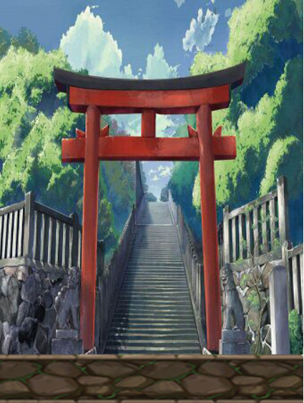

## 

## 1.10 Market Analysis

**Main market**: this game is for 12-26-year-olds young people. The game is very challenging and interesting, so the users are very sticky, and children will keep trying the game to get higher and higher scores. Old people generally like leisure games and do not like challenging games. Middle-aged people are more stressful in life and work, so challenging games have a low new attraction for them. This game consumes less time and requires less time. It can be played at any time and can effectively make use of the fragmentation time of young people.

**Competitive advantage**: this game is different from ordinary APP. It is designed and published through the website. It can adapt to a variety of environments and platforms and has strong compatibility. And there is almost nothing to pay for, and there are no advertisements, which is more attractive to consumers. It's easy to play with and full of fun. The game ‘s user interface is as simple and clear as possible. Considering that young people are good at receiving information, the game is equipped with rich animation and music to provide users with appropriate feedback.

# Functional Specification

## Navigation

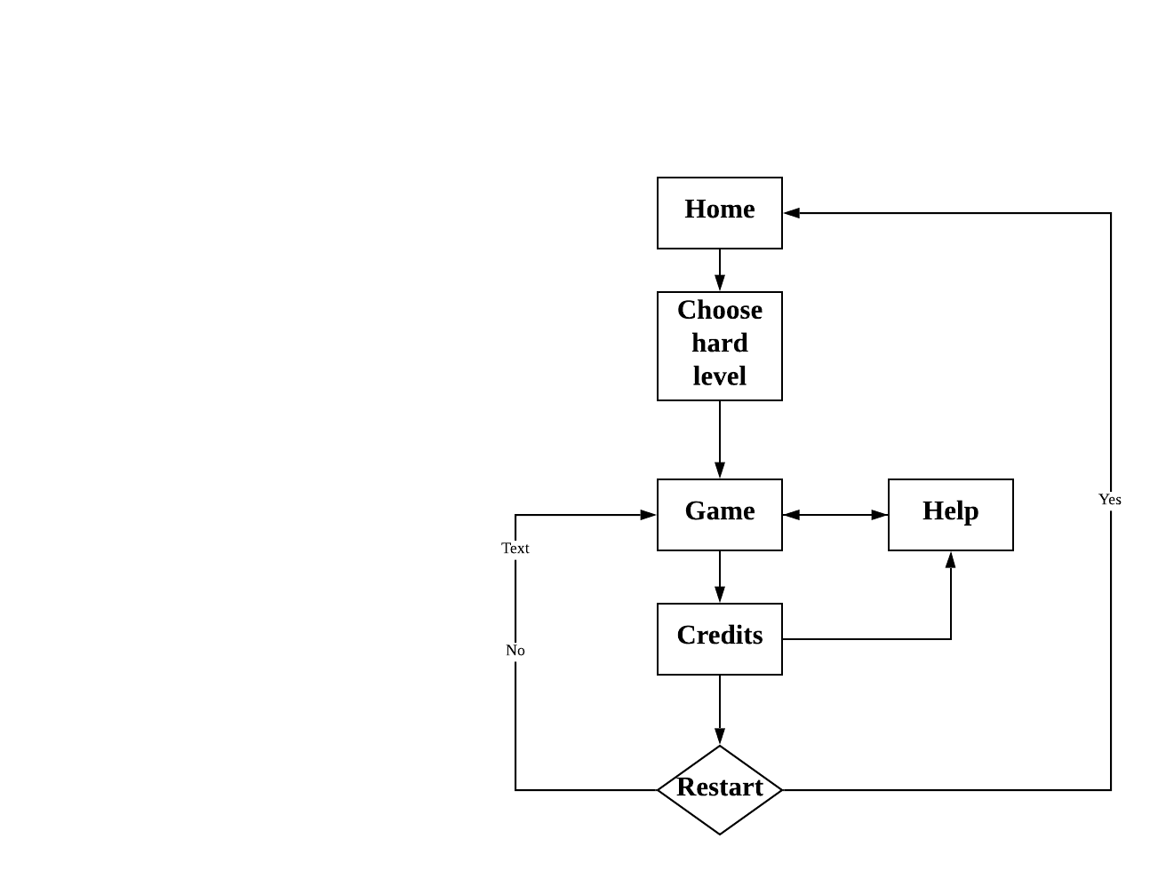

## User Interface

Home Page:

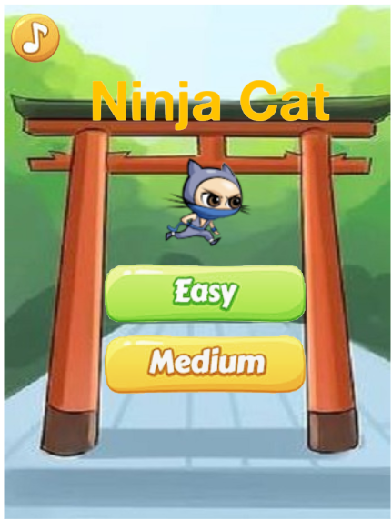

Help Page:

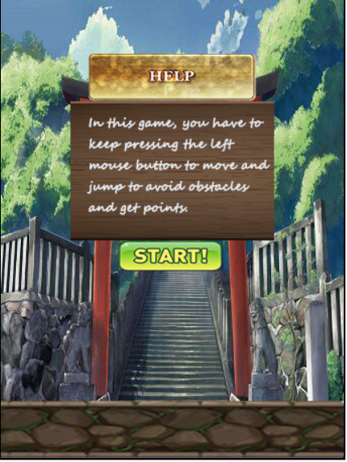

Credit Page:

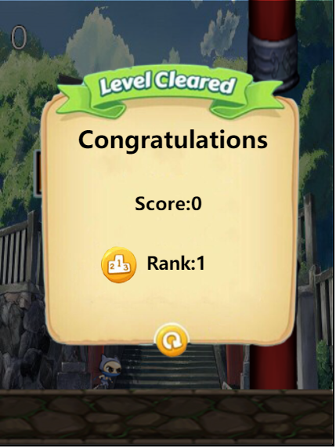

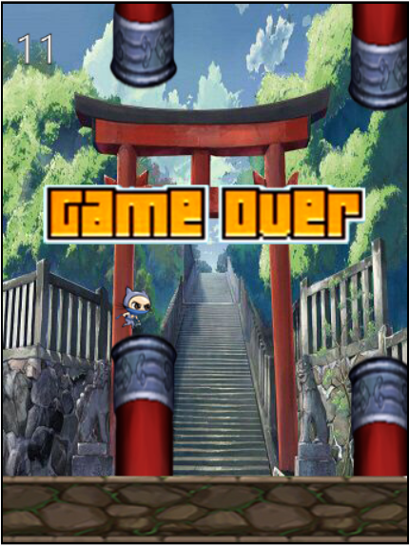Play1 Page (easy rank):

Play2 Page (medium rank):



## Storyboards

**Title**: Home Page **Frame ID**: Home

**Dimensions: In this scenario, I use the larger size: 350*453 pixels.**

**Media Used:**

**SCENE LOEADING: When the page appears, the game character will be placed on easy button as a beating logo.** **In addition, the media files and corresponding scripts in the game will be loaded continuously.**

**IMAGE: The background image is about** Shintoism**. Next to the theme is the main character of the game, and a picture.**

**Buttons: Under the title, there are three buttons, respectively easy button, mute button and medium button.**

**Background**: The background is about Shintoism.

**Content: The content of this page includes three excellent user buttons to choose the difficulty of the game. In addition, there is a Shinto background map about the Ninja story, a title icon and a dynamic character icon.**

**Description (purpose / objectives):**

This page is for users to choose how to start the game. Users can choose to

play directly game. This is the home page of the game, provide navigation to each different page

**Animations:**

**The character Icon above the easy button is animated.**

**Ninja cats are constantly running around the page**

**The mouse will turn to pointer**

**User Interactions Required:**

User can click easy button to enter the easy game.

User can click medium button to the medium game.

User can click music button to turn on/off the music

**Navigation / Links:**

* Navigation to easy page
* Navigation to medium page

Links to wireframes: <https://gomockingbird.com/projects/bcu4v9s/4gXVnC>

**Title**: Play Page1 **Frame ID**: *Play1.0*

**Dimensions: In this scenario, I use the larger size: 350*453 pixels.**

**Media Used:**

**SOUNDS: When this page appears, a background music will play.**

**Jump music: You will hear music when you let the character jump**

**Death music: You will hear dead music when you crash with the tube**

**SCENE LOEADING: When the page loads, you will find some obstacles moving.**

**IMAGE: The background image is a Shintoism. Both the obstacles and character are pictures.**

**Character: The character image is a Ninja Cat. Player will control it begin their big adventure**

**Obstacle: The page will generate some obstacles, the player needs to evade them**

**Background**: The background is about a Shintoism.

**Content: This page is the easy game page. In order to rescue the princess through multiple levels, the player has to control the ninja to jump and avoid obstacles and possible cannibals.**

**Description (purpose / objectives):**

This is the main page of the game on which the player plays the game.

Players need to avoid obstacles to achieve higher scores.

The difficulty of this page is simple.

**Animations:**

**When the player controls the player to jump, the ninja cat animates the jump.**

**Players will see open/closed man-eating flowers**

**User Interactions required:**

User can click the screen to play this game.

**User feedback:**

Player will hear jump sound when they jump

Player will hear death sound when they dead

Player will hear background music if they open it

Player will see jumped ninja cat

Player will see **open/closed man-eating flowers**

Links to wireframes: <https://gomockingbird.com/projects/bcu4v9s/4gXVnC>

**Title**: Play Page2 **Frame ID**: *Play2.0*

**Dimensions: In this scenario, I use the larger size: 350*453 pixels.**

**Media Used:**

**SOUNDS: When this page appears, a background music will play.**

**Jump music: You will hear music when you let the character jump**

**Death music: You will hear dead music when you crash with the tube**

**SCENE LOEADING: When the page loads, you will find some obstacles moving.**

**IMAGE: The background image is a Shintoism. Both the obstacles and character are pictures.**

**Character: The character image is a Ninja Cat. Player will control it begin their big adventure**

**Obstacle: The page will generate some obstacles, the player needs to evade them**

**Background**: The background is about a Shintoism.

**Content: This page is the more difficult game page. In order to rescue the princess through multiple levels, the player has to control the ninja to jump and avoid obstacles and possible cannibals.**

**Description (purpose / objectives):**

This is the main page of the game on which the player plays the game.

Players need to avoid obstacles to achieve higher scores.

The difficulty of this page is simple.

**Animations:**

**When the player controls the player to jump, the ninja cat animates the jump.**

**Players will see open/closed man-eating flowers**

**User Interactions required:**

User can click the screen to play this game.

**User feedback:**

Player will hear jump sound when they jump

Player will hear death sound when they dead

Player will hear background music if they open it

Player will see jumped ninja cat

Player will see **open/closed man-eating flower**

Links to wireframes: <https://gomockingbird.com/projects/bcu4v9s/4gXVnC>

**Title**: Help Page **Frame ID**: *help*

**Dimensions: In this scenario, I use the larger size: 350*453 pixels.**

**Media Used:**

**SOUNDS: When this page appears, a background music will play.**

**IMAGE: The background image is Shintoism.**

**Buttons: There is a start button in the centre of page.**

**Background**: The background is about Shintoism.

**Content: This page is about the background of the game and how users operate it. This page contains a start button.**

**Description (purpose / objectives):**

This page is help users guide how to play the game.

This is a help page which goal is to help users understand the basic gameplay of the

game and to make sure the player is ready for the game.

**User Interactions Required:**

User can click start button to start the game.

**Navigation / Links:**

* Navigation to Play page

Links to wireframes: https://gomockingbird.com/projects/bcu4v9s/4gXVnC

**Title**: Credit Page **Frame ID**: *Credit*

**Dimensions: In this scenario, I use the larger size: 350*453 pixels.**

**Media Used:**

**IMAGE: The background image is about Shintoism.**

**Restart；A restart icon used as a restart button**

**Buttons: There is a restart button in the page.**

**Background**: The background is about a Shintoism.

**Content: This page contains a restart button.**

**Description (purpose / objectives):**

This is the score page of the game. Players can see their scores and rankings through the

score meeting, stimulate players' interest in the challenge, and get relevant feedback.

The page provides buttons to restart the game.

**Animation:**

Users will see the game's screen darken and the score screen emerge from the page,

showing the user's score and ranking.

**User Interactions Required:**

User can click restart button to enter the play page.

**User feedback:**

Player will see the score screen emerge from the game's interface, showing the

Player's score and ranking. It provides a restart button to start the game again.

**Navigation / Links:**

* Navigation to the play page

Links to wireframes: https://gomockingbird.com/projects/bcu4v9s/4gXVnC

## Media List

|  |  |
| --- | --- |
| Image name or description | Resource address/URL |
| **Audio:**  **Image:**  Character image:  Board image:  Background image:  Pole image  Another image | sc.chinaz.com. (n.d.). 死亡音效下载_死亡音效大全. [online] Available at: http://sc.chinaz.com/tag_yinxiao/SiWang.html [Accessed 26 May 2020].  ‌  www.aigei.com. (n.d.). *《忍者猫》游戏素材_合集素材-游戏素材下载 - 爱给网*. [online] Available at: http://www.aigei.com/view/71281.html#items [Accessed 26 May 2020].  www.aigei.com. (n.d.). *%E6%9C%A8%E6%9D%BF - 免费下载 - 爱给网*. [online] Available at: http://www.aigei.com/s?q=%E6%9C%A8%E6%9D%BF [Accessed 26 May 2020a].  ‌ www.win4000.com. (n.d.). *二次元动漫场景图片高清电脑壁纸-卡通动漫-壁纸下载-美桌网*. [online] Available at: http://www.win4000.com/wallpaper_detail_147895_3.html [Accessed 26 May 2020].  ‌ www.aigei.com. (n.d.). *%E6%9F%B1%E5%AD%90 - 游戏 免费下载 - 爱给网*. [online] Available at: http://www.aigei.com/s?q=%E6%9F%B1%E5%AD%90&type=game [Accessed 26 May 2020b].  ‌ www.6m5m.com. (n.d.). *卡通游戏立体界面及按钮ui图标资源,按钮图标,UI,6m5m游戏素材*. [online] Available at: http://www.6m5m.com/service-sid-34368.html [Accessed 26 May 2020]. |

# Technical Specification

## Technical Specs: Minimum Requirements

Chrome 80.0.3987.149 (official version) (64 bit)

The recommended version: Chrome 80.0.3987.149 (official version) (64 bit)

The game runs in Chrome, Safari, Firefox 3.6, and Opera 10.5. IE Internet explorer is not very well supported, and it is recommended to run in IE9+ or above.

## Technical Specs: Code Objects

function RunGame(speed) {

var updateTimer = set Interval(function() {

if (start the scorer) {

var scoreTimer = setInterval(function() {

if (game.gameOver) {

clearInterval(scoreTimer);

return;

}

game.score++;

}, game.obsInterval);

}

game.CanMove();

if (game over) {

show “game over”;

Clear interval time;

return;

}

Game over and show scores;

}, speed);

set Interval(function() {

if (game over) {

Clear interval time;

return;

}

Create object;

}, interval time);

}

function InitGame() {

Create a map;

canvas.onmousedown = function() {

game’s touch equals true;

}

canvas.onmouseup = function() {

game’s touch equals false;

};

canvas.onclick = function() {

if (check played) {

adjust function play and game loading speed }

}

}

## Technical Specs: Data Handling

|  |  |
| --- | --- |
| Data Handling | Action |
| Database: | local storage |
| Data in the file instance: | Scores: int |

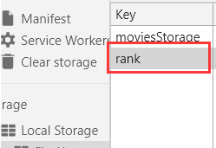

# User Evaluation and Testing forms

## User Evaluation forms

User Testing Form 1

1. I am 13 years old.
2. I am a… Boy 🗹 Girl 🞎
3. There were no errors when I played the game.

|  |  |  |  |  |
| --- | --- | --- | --- | --- |
| *strongly agree* | *agree* | *neutral* | *disagree* | *strongly disagree* |
| 🗹 | 🞎 | 🞎 | 🞎 | 🞎 |

1. I found it is not difficult to get a high grade at this game.

|  |  |  |  |  |
| --- | --- | --- | --- | --- |
| *strongly agree* | *agree* | *neutral* | *disagree* | *strongly disagree* |
| 🞎 | 🗹 | 🞎 | 🞎 | 🞎 |

1. I never found myself being frustrated while playing this game.

|  |  |  |  |  |
| --- | --- | --- | --- | --- |
| *strongly agree* | *agree* | *neutral* | *disagree* | *strongly disagree* |
| 🞎 | 🗹 | 🞎 | 🞎 | 🞎 |

1. The animations were very smooth.

|  |  |  |  |  |
| --- | --- | --- | --- | --- |
| *strongly agree* | *agree* | *neutral* | *disagree* | *strongly disagree* |
| 🗹 | 🞎 | 🞎 | 🞎 | 🞎 |

1. The animations added to my enjoyment playing the game.

|  |  |  |  |  |
| --- | --- | --- | --- | --- |
| *strongly agree* | *agree* | *neutral* | *disagree* | *strongly disagree* |
| 🗹 | 🞎 | 🞎 | 🞎 | 🞎 |

1. I can get hold of the rule of this game easily.

|  |  |  |  |  |
| --- | --- | --- | --- | --- |
| *strongly agree* | *agree* | *neutral* | *disagree* | *strongly disagree* |
| 🗹 | 🞎 | 🞎 | 🞎 | 🞎 |

1. This game has good-looking interface.

|  |  |  |  |  |
| --- | --- | --- | --- | --- |
| *strongly agree* | *agree* | *neutral* | *disagree* | *strongly disagree* |
| 🗹 | 🞎 | 🞎 | 🞎 | 🞎 |

1. All the audios tone well with this website.

|  |  |  |  |  |
| --- | --- | --- | --- | --- |
| *strongly agree* | *agree* | *neutral* | *disagree* | *strongly disagree* |
| 🞎 | 🗹 | 🞎 | 🞎 | 🞎 |

1. What do you dislike most about the game?

|  |  |  |  |  |
| --- | --- | --- | --- | --- |
| *It takes a lot of energy* | *It takes a lot of money* | *It's not pleasant to play* | *The picture is too rough* | *The game is too monotonous* |
| 🞎 | 🞎 | 🞎 | 🞎 | 🗹 |

1. What is the most attractive content in the game?

|  |  |  |  |  |
| --- | --- | --- | --- | --- |
| *Exquisite picture quality* | *Perfect sound quality* | *Practical, great help for players* | *Skill effects with strong visual impact* | *Anything else* |
| 🞎 | 🞎 | 🞎 | 🞎 | 🗹 |

13. What do you think needs to be improved in the game?

The game background picture is too monotonous. I hope that the background picture can be changed constantly.

1. Please talk about your overall evaluation of this questionnaire.

The questionnaire is very detailed and rich in content.

15. Please leave your contact information so that we can provide better service

WeChat: 1572203120830

User Testing Form 2

1. I am 11 years old.
2. I am a… Boy 🞎 Girl 🗹
3. There were no errors when I played the game.

|  |  |  |  |  |
| --- | --- | --- | --- | --- |
| *strongly agree* | *agree* | *neutral* | *disagree* | *strongly disagree* |
| 🗹 | 🞎 | 🞎 | 🞎 | 🞎 |

1. I found it is not difficult to get a high grade at this game.

|  |  |  |  |  |
| --- | --- | --- | --- | --- |
| *strongly agree* | *agree* | *neutral* | *disagree* | *strongly disagree* |
| 🗹 | 🞎 | 🞎 | 🞎 | 🞎 |

1. I never found myself being frustrated while playing this game.

|  |  |  |  |  |
| --- | --- | --- | --- | --- |
| *strongly agree* | *agree* | *neutral* | *disagree* | *strongly disagree* |
| 🗹 | 🞎 | 🞎 | 🞎 | 🞎 |

1. The animations were very smooth.

|  |  |  |  |  |
| --- | --- | --- | --- | --- |
| *strongly agree* | *agree* | *neutral* | *disagree* | *strongly disagree* |
| 🞎 | 🗹 | 🞎 | 🞎 | 🞎 |

1. The animations added to my enjoyment playing the game.

|  |  |  |  |  |
| --- | --- | --- | --- | --- |
| *strongly agree* | *agree* | *neutral* | *disagree* | *strongly disagree* |
| 🞎 | 🗹 | 🞎 | 🞎 | 🞎 |

1. I can get hold of the rule of this game easily.

|  |  |  |  |  |
| --- | --- | --- | --- | --- |
| *strongly agree* | *agree* | *neutral* | *disagree* | *strongly disagree* |
| 🞎 | 🗹 | 🞎 | 🞎 | 🞎 |

1. This game has good-looking interface.

|  |  |  |  |  |
| --- | --- | --- | --- | --- |
| *strongly agree* | *agree* | *neutral* | *disagree* | *strongly disagree* |
| 🞎 | 🗹 | 🞎 | 🞎 | 🞎 |

1. All the audios tone well with this website.

|  |  |  |  |  |
| --- | --- | --- | --- | --- |
| *strongly agree* | *agree* | *neutral* | *disagree* | *strongly disagree* |
| 🞎 | 🗹 | 🞎 | 🞎 | 🞎 |

1. What do you dislike most about the game?

|  |  |  |  |  |
| --- | --- | --- | --- | --- |
| *It takes a lot of energy* | *It takes a lot of money* | *It's not pleasant to play* | *The picture is too rough* | *The game is too monotonous* |
| 🞎 | 🞎 | 🗹 | 🞎 | 🞎 |

1. What is the most attractive content in the game?

|  |  |  |  |  |
| --- | --- | --- | --- | --- |
| *Exquisite picture quality* | *Perfect sound quality* | *Practical, great help for players* | *Skill effects with strong visual impact* | *Anything else* |
| 🞎 | 🞎 | 🞎 | 🞎 | 🗹 |

13. What do you think needs to be improved in the game?

Game content is not rich enough.

1. Please talk about your overall evaluation of this questionnaire.

The questionnaire is very detailed and rich in content.

15. Please leave your contact information so that we can provide better service

Tel: 4008-823-824

User Testing Form 3

1. I am 12 years old.
2. I am a… Boy 🗹 Girl 🞎
3. There were no errors when I played the game.

|  |  |  |  |  |
| --- | --- | --- | --- | --- |
| *strongly agree* | *agree* | *neutral* | *disagree* | *strongly disagree* |
| 🗹 | 🞎 | 🞎 | 🞎 | 🞎 |

1. I found it is not difficult to get a high grade at this game.

|  |  |  |  |  |
| --- | --- | --- | --- | --- |
| *strongly agree* | *agree* | *neutral* | *disagree* | *strongly disagree* |
| 🞎 | 🗹 | 🞎 | 🞎 | 🞎 |

1. I never found myself being frustrated while playing this game.

|  |  |  |  |  |
| --- | --- | --- | --- | --- |
| *strongly agree* | *agree* | *neutral* | *disagree* | *strongly disagree* |
| 🗹 | 🞎 | 🞎 | 🞎 | 🞎 |

1. The animations were very smooth.

|  |  |  |  |  |
| --- | --- | --- | --- | --- |
| *strongly agree* | *agree* | *neutral* | *disagree* | *strongly disagree* |
| 🞎 | 🗹 | 🞎 | 🞎 | 🞎 |

1. The animations added to my enjoyment playing the game.

|  |  |  |  |  |
| --- | --- | --- | --- | --- |
| *strongly agree* | *agree* | *neutral* | *disagree* | *strongly disagree* |
| 🗹 | 🞎 | 🞎 | 🞎 | 🞎 |

1. I can get hold of the rule of this game easily.

|  |  |  |  |  |
| --- | --- | --- | --- | --- |
| *strongly agree* | *agree* | *neutral* | *disagree* | *strongly disagree* |
| 🞎 | 🗹 | 🞎 | 🞎 | 🞎 |

1. This game has good-looking interface.

|  |  |  |  |  |
| --- | --- | --- | --- | --- |
| *strongly agree* | *agree* | *neutral* | *disagree* | *strongly disagree* |
| 🞎 | 🗹 | 🞎 | 🞎 | 🞎 |

1. All the audios tone well with this website .

|  |  |  |  |  |
| --- | --- | --- | --- | --- |
| *strongly agree* | *agree* | *neutral* | *disagree* | *strongly disagree* |
| 🗹 | 🞎 | 🞎 | 🞎 | 🞎 |

1. What do you dislike most about the game?

|  |  |  |  |  |
| --- | --- | --- | --- | --- |
| *It takes a lot of energy* | *It takes a lot of money* | *It's not pleasant to play* | *The picture is too rough* | *The game is too monotonous* |
| 🞎 | 🞎 | 🞎 | 🗹 | 🞎 |

1. What is the most attractive content in the game?

|  |  |  |  |  |
| --- | --- | --- | --- | --- |
| *Exquisite picture quality* | *Perfect sound quality* | *Practical, great help for players* | *Skill effects with strong visual impact* | *Anything else* |
| 🞎 | 🗹 | 🗹 | 🗹 | 🞎 |

13. What do you think needs to be improved in the game?

Not enough rewards for the game.

1. Please talk about your overall evaluation of this questionnaire.

The questionnaire is very detailed and rich in content

15. Please leave your contact information so that we can provide better service

QQ：2430923023

## Product Testing forms

1. Your age is: ___15___
2. Your gender is: __Female____
3. When do you usually play this game?

|  |  |  |
| --- | --- | --- |
| *Bored* | *Free time* | *Anything else* |
| 🞎 | 🗹 | 🞎 |

1. How often do you play the game?

|  |  |  |  |  |
| --- | --- | --- | --- | --- |
| *Often* | *Always* | *Sometimes* | *Seldom* | *No play* |
| 🞎 | 🗹 | 🞎 | 🞎 | 🞎 |

1. How does this game compare to other brands of games?

|  |  |  |  |  |
| --- | --- | --- | --- | --- |
| *Much Better* | *Better* | *About the same* | *Worse* | *Much Worse* |
| 🗹 | 🞎 | 🞎 | 🞎 | 🞎 |

1. Is for people like me?

|  |  |  |  |  |
| --- | --- | --- | --- | --- |
| *strongly agree* | *agree* | *neutral* | *disagree* | *strongly disagree* |
| 🗹 | 🞎 | 🞎 | 🞎 | 🞎 |

1. Is good quality?

|  |  |  |  |  |
| --- | --- | --- | --- | --- |
| *strongly agree* | *agree* | *neutral* | *disagree* | *strongly disagree* |
| 🗹 | 🞎 | 🞎 | 🞎 | 🞎 |

1. Is worth playing a little more for

|  |  |  |  |  |
| --- | --- | --- | --- | --- |
| *strongly agree* | *agree* | *neutral* | *disagree* | *strongly disagree* |
| 🞎 | 🗹 | 🞎 | 🞎 | 🞎 |

9. There were no errors when I played the game.

|  |  |  |  |  |
| --- | --- | --- | --- | --- |
| *strongly agree* | *agree* | *neutral* | *disagree* | *strongly disagree* |
| 🗹 | 🞎 | 🞎 | 🞎 | 🞎 |

10. The animations were very smooth.

|  |  |  |  |  |
| --- | --- | --- | --- | --- |
| *strongly agree* | *agree* | *neutral* | *disagree* | *strongly disagree* |
| 🗹 | 🞎 | 🞎 | 🞎 | 🞎 |

11. The animations added to my enjoyment playing the game.

|  |  |  |  |  |
| --- | --- | --- | --- | --- |
| *strongly agree* | *agree* | *neutral* | *disagree* | *strongly disagree* |
| 🗹 | 🞎 | 🞎 | 🞎 | 🞎 |

12. I can get hold of the rule of this game easily.

|  |  |  |  |  |
| --- | --- | --- | --- | --- |
| *strongly agree* | *agree* | *neutral* | *disagree* | *strongly disagree* |
| 🗹 | 🞎 | 🞎 | 🞎 | 🞎 |

13. This game has good-looking interface.

|  |  |  |  |  |
| --- | --- | --- | --- | --- |
| *strongly agree* | *agree* | *neutral* | *disagree* | *strongly disagree* |
| 🗹 | 🞎 | 🞎 | 🞎 | 🞎 |

14. All the audios tone well with this website.

|  |  |  |  |  |
| --- | --- | --- | --- | --- |
| *strongly agree* | *agree* | *neutral* | *disagree* | *strongly disagree* |
| 🗹 | 🞎 | 🞎 | 🞎 | 🞎 |

15. Do you have any suggestions how we can improve this game? Please be as specific as possible:

The picture should be better and more difficult at different levels. Suggestions to improve the fun of the game.